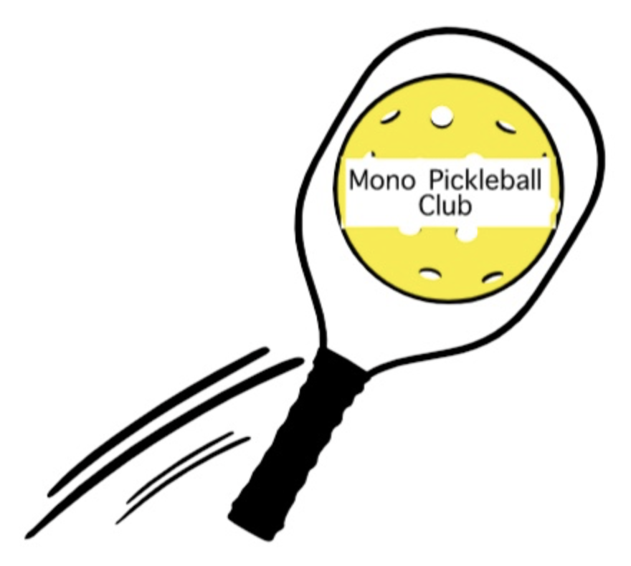
Mono Pickleball Club Newsletter #10
May 28th, 2023

“Mono Pickleball Club Day”
Special Event :
For Fun, For Fitness, for All …and for the Future
Mini tournaments, mini clinics, social activities, food. View the new MCP layout, discuss options for winter play, and visit with your pickleball friends.
All MPC members are welcome. There may be a minimal fee, but we anticipate a grant from Pickleball Ontario will cover most of the cost. Exact date and time TBD, and will be on the website,
Save the Date July 30th (tentative).

FUNDraising Trivia Night
Potluck FUNDraising Team Trivia Night – Saturday June 17th, 6 pm at the former
Covenant Alliance Church, 3 Zina Street Orangeville.
Bring an appetizer or dessert to share.
BYOB; soft drinks and sparkling water will be available as well as coffee and tea.
You will play in teams of 4 or 6. (You can make your own team or be assigned to a team when you arrive).
Categories will include pickleball!
Friends, Family and neighbours welcome to this event.
Click < here > to register.

Clinics:
Three MPC pickleball clinics have been completed by our NCCP coaches. Many participants are new members and beginners, please welcome them onto the court and continue to encourage them. More clinics are being planned with varying formats, and if you are interested please add your name on the
< waitlist > and you will be contacted soon.

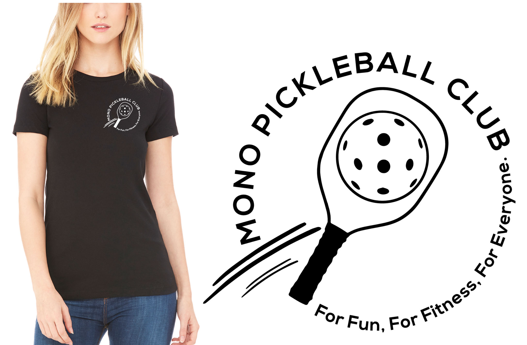
MPC T-Shirts and Swag:
Available soon under “shop” on our website.
Note that our logo is slightly redesigned and includes our slogan. There will be a choice of shirts and colours available, as well as a few other items.
Each sale will benefit the club, and most importantly you can show that you are a proud member of Mono Pickleball Club.

Mono College Park (MCP) Courts Reconstruction:
The renewal of the present surface at MCP into 6 dedicated pickleball courts will begin soon.
Your Board continues to work with the Town of Mono and the contractors to ensure the needs of you, our members, are considered. It’s going to be exciting to watch the MPC ‘Home’ develop.

Outdoor Pickleball 2023:
Outdoor play for MPC members has begun at Lions Sport Pad (LSP). Four days/week up to 30 members of MPC gather on the 5 courts for pickleball, socialization, fun and fitness. This initial 7-week session ends in early July. The next session, when finalized, will be posted on the website for members to register. Location, times and fees to be determined.

Net Lending Program:
Mono Pickleball Club members may borrow a net on a short-term basis to use with a small group (no fee). If you are interested in taking advantage of this opportunity for fun, for fitness and for all, please contact < MonoPickleballClub@gmail.com > with the subject line “Net Lending”.
Tournaments:
Congratulations to our MPC members who have been making a positive presence around the province at various tournaments – some fun and some sanctioned.

MPC Website
The website continues to be the go to for information on membership/registration,
playing times, clinics, upcoming events, links to everything Pickleball, . . . MonoPickleballClub.com

