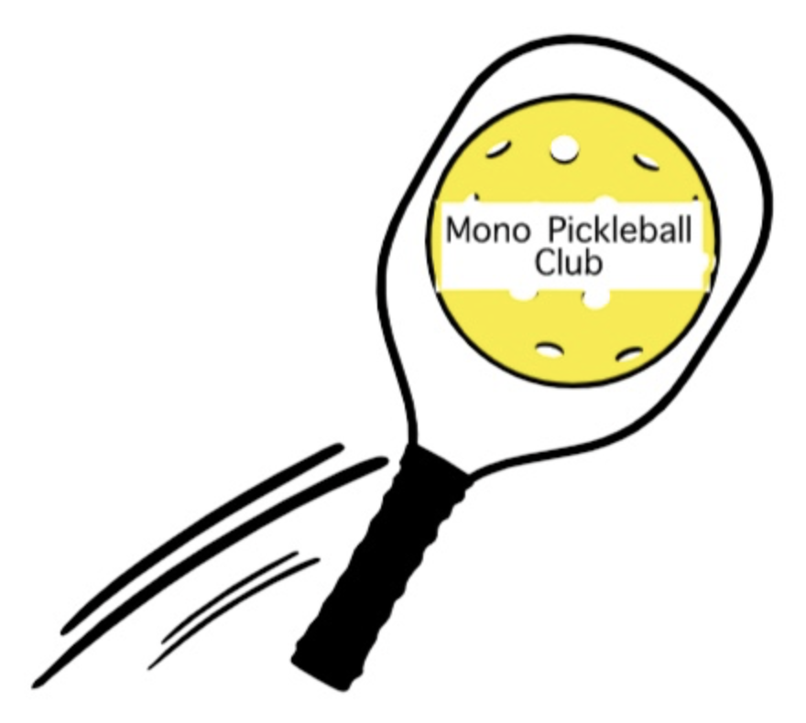
Mono Pickleball Club Newsletter #9
April 22nd, 2023

Mono College Park (MCP) Courts Reconstruction:
The renewal of the present surface into 6 dedicated pickleball courts, each individually fenced, with new lighting is scheduled for June 1 - Sept 1st, 2023. The courts will not be safe for use until post reconstruction. At that time the “new home” of Mono Pickleball Club will be outstanding in its field.
Funds from the Trillium Grant, the New Horizon for Seniors Program, and the Town of Mono will go towards this major venture. The MPC Board continues to play a significant role thought-out, and have open communication and consultation with the engineers, contractors and the Town of Mono along this significant journey.

Outdoor Pickleball 2023:
Options for outdoor play for MPC members for this season has been ongoing by the Board. It was determined that four 2-hour slots at Lions Sport Pad (LSP) would meet the needs of our membership based on the survey sent out last week. When the requested days and time slots have been confirmed by the Town of Orangeville you will be notified of additional details and registration via email.
Note: a fifth court will be added to the present 4 courts at LSP thus a maximum of 30 players will be able to register for each session. Members will be able to register for 1, 2, 3 or 4 sessions per week as numbers permit.

Net Lending Program:
Mono Pickleball Club members may borrow a net on a short-term basis to use with a small group. More details will be on the website soon. If you are interested in taking advantage of this opportunity, please contact < MonoPickleballClub@gmail.com > with the subject line “Net Lending”.

Fundraising:
Euchre Tourney April 14th: Another successful FUNdraiser was enjoyed by MPC members and friends with home made pizza, snacks and goodies, great conversations, laughter and good fun competition.
Make Mono Shine April 22nd: A further fundraiser for MPC of home-made cookies, muffins, butter tarts, as well as samosas and hot dogs were available at ‘Make Mono Shine” for all the hungry, and wet, participants for this community event.
Pictures of these events can be seen on the MPC website.
Trivia Night: Coming in June! Potluck FUNdraiser Team Trivia event. Details to follow.

Clinics:
The first MPC lead pickleball clinic was completed April 20th at Compass Community Church gym. Participants expressed their appreciation for help in improving their pickleball strategies and skills. More clinics are being planned.
MPC Website
The website continues to be the go to for information on membership/registration,
playing times, clinics, upcoming events, links to everything Pickleball, . . . MonoPickleballClub.com

