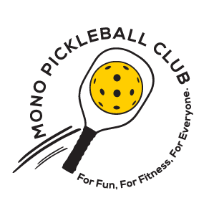
Mono Pickleball Club
Newsletter #16 – November 15, 2023

In this edition:
- MCP Courts
- MPC’s Annual Holiday Gathering – Register soon
- 2024 Membership renewals
- MPC at AI – Winter and Spring Session Registrations
Mono College Park Courts
After the completion of MCP courts on October 15th they were enjoyed by MPC members. These courts will now be permanently closed until the spring starting Thursday November 16th at 3:30 pm. We are looking forward to having a “smashing” Open House in the spring, and playing loads of Pickleball next spring, summer and fall on this beautiful new facility.
MPC’s Annual Holiday Gathering – Thursday December 7th
When: Thursday, December 7th from 4pm - 8pm. Drop in at any time.
Who: MPC members and their spouse/partner.
Where: Watermark party room located at 49 Watermark Drive, Mono.
Bring: (1) An appetizer or dessert to share. (2) Your own non-alcoholic drinks and/or BYOB. (3) Indoor shoes. Please register yourself and a non-member spouse/partner. Maximum of 60 people can attend.
There is no cost for this event however there will be a donation jar at the party and raffle draws. (Tickets will be priced at $2 each or 3 for $5.) Also, please bring gently used puzzles or recent books that will be available for purchase for a $5 donation. All proceeds go to MPC.
Questions: Contact Sally at flowerpower50.sc@gmail.com.
2024 Membership Renewal Date and Registration
Current 2023 members of MPC can now renew their membership for 2024 using the following link: https://pickleballcanada.org/club/MonoPickleballClub
Membership fees for 2024 are:
- MPC member renewal - early bird October 1st until December 1st 2023 - $50
- MPC member renewal - after December 1st, 2023 - $60
- PAO (Pickleball Ontario) - $10 (required for membership)
- PCO (Pickleball Canada) - $10 (required for membership)
Note: Membership is presently closed for new registrants and will open in 2024, with Membership fees as above. If you wish to maintain your membership for 2024 we suggest doing so before new memberships open, as MPC will likely maintain a membership cap.
MPC Indoors at the Athlete Institute – Winter and Spring Sessions
Registration for the Winter (January 8 – March 22, 2024, 10 weeks) and Spring (March 25 – May 3, 2024, 6 weeks) Sessions are now open for registration with limited spots available. To register see links below:
Winter: https://pickleballcanada.org/event/AthleteInstitute_Winter2024
Spring: https://pickleballcanada.org/event/AthleteInstitute_Spring2024
NOTE: You must be a 2024 member to register for either of these sessions. If you signed up for the complete season (Fall, Winter and Spring) remember to renew your membership before resuming play in 2024.

