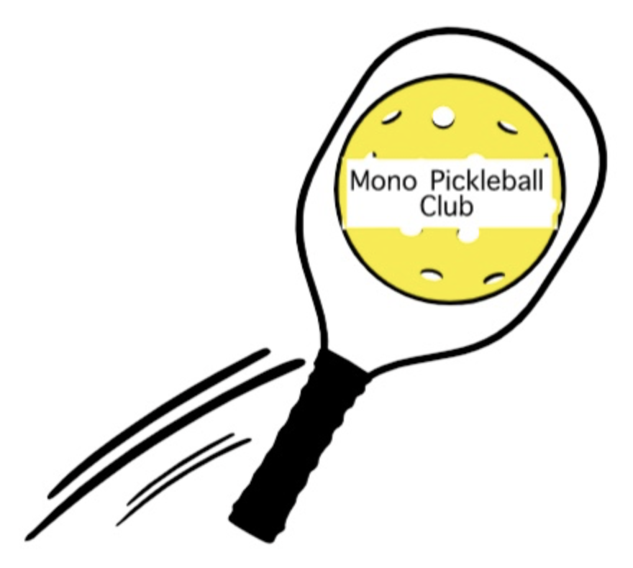
Mono Pickleball Club Newsletter #8
February 22nd, 2023

Great News:
Mono Pickleball Club has been awarded the New Horizon for Seniors Program (NHSP) grant of the full amount of the application: $24 481. The considerable time and effort required to apply has been a worthwhile learning experience. The funds will contribute to the completion of the 6 dedicated pickleball courts at Cardinal Woods (Mono College Park aka MCP). Close attention and additional documentation is required to specific aspects of the reconstruction in order to receive the NHSP grant monies.

Volunteers Needed:
MPC is a non-profit, volunteer, community organization with a Board of Directors, est 2022. A great deal of work has been done by a relatively small group of volunteers to create a thriving club; a few of these are fundraising, advocating for PB in the community, renting indoor space, creating websites, communicating with community, Pickleball Ontario and Pickleball Canada. The reconstruction of the courts between May and October 2023 requires input and overseeing by the Board, thus some duties being done by the Executive will need to be allocated to other volunteer members of MPC.
PLEASE think about your strengths and if you are willing to volunteer for any aspect let us know
< MonoPickleballClub@gmail.com >

Fundraising Event at Winterfest 2023:
Thank you to those who volunteered at Winterfest – making and selling food. MPC was successful in making over $1000. Check the MPC website to see photos and Sally and Beth’s account of the day.

Indoor Pickleball:
MPC members are continuing to play indoors at Headwaters Racquet Club (HRC), Compass Community Church (CCC), and Westside Secondary School. The registrations fill up quickly and it is unfortunate there are not more places to rent space locally. Some people travel to Fergus, Brampton or Waterloo where courts are available. The Saputo Centre at Alder Rec Complex is a popular spot to reserve a spot to play.

Outdoor Pickleball 2023:
There may be an opportunity for MPC members to play at MCP before construction begins. Keep an eye on the website for details when they become available.
Once MCP construction begins, these courts will be unavailable, and we are presently considering other outdoor venues when this occurs. There will likely be a rental fee and registration involved.
Alternatively, HRC has offered the community an outdoor pickleball “membership” which runs from mid-May – mid-October for $150. Although this is not a MPC sponsored opportunity it might be of interest to you. See the attached flyer.

Clinics:
Several MPC members have successfully completed the requirements and are now Level 1 Coaches/Instructors. Beginners and novices might be interested in being involved in a clinic at a nominal fee. More information will be on the website when it becomes available.
MPC Website
The website continues to be the go to for information on membership/registration,
playing times, clinics, upcoming events,
links to everything Pickleball, . . . MonoPickleballClub.com

